Test plan for Skills Demo 1

Test 1

Test that the getPrice() method returns the right price:

* Length = 100
* Width = 100
* Rooms = 10
* Windows = 10
* Stories = 3

Expected result: The program should return the Price of the house to be €3,000,000

Actual result: The program returned the correct amount

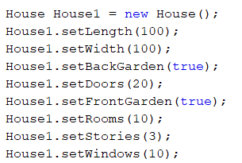



Test 2

Test that the getRentalPrice() method returns the right price:

* Length = 100
* Width = 100
* Rooms = 10
* Windows = 10
* Stories = 3

Expected result: The program should return the Price of the rent to be €7,500

Actual result: The program returned the correct amount





Test 3

Test that the getInsurancePremium() method returns the right price:

* Length = 100
* Width = 100
* Rooms = 10
* Windows = 10
* Stories = 3

Expected result: The program should return the Price of the Insurance to be €60,000

Actual result: The program returned the correct amount





Test 4

Test that the user input works

* Length = 100
* Width = 100
* Rooms = 10
* Windows = 10
* Stories = 3
* Doors = 10
* Front garden = true
* Back garden = false

Expected Result: The program takes all the input correctly

Actual result: The program took all the input correctly

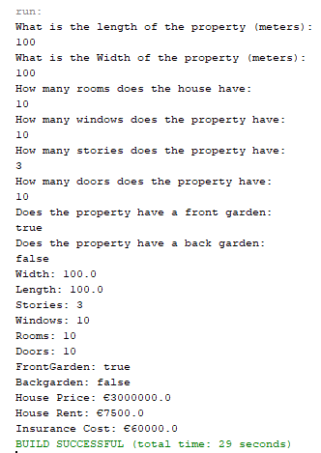

Test 5

Test that the attractive screen display method works

Expected result: The stars will align and it’ll look nice

Actual result: It looks okay

